1. **Description of dataset’s characteristics**

The analysis concerns the phenomenon of diabetes and its causes. The goal of the analysis is to check which factors have the greatest impact on the risk of developing diabetes.

The domain of our project is healthcare. The source of the dataset is Kaggle. The study included women from 21 years of age of Pima Indian heritage. Dataset contains 9 variables and each of them has 768 entries. All variables are quantitative.

|  |  |  |
| --- | --- | --- |
| Variables | Description | Variable type |
| Pregnancies | Number of times pregnant | Discrete (int) |
| Glucose | Glucose level in blood | Discrete (int) |
| Blood pressure | Blood pressure measurement (mm Hg) | Discrete (int) |
| Skin thickness | Thickness of the skin (mm) | Discrete (int) |
| Insulin | Insulin level in blood (mu U/ml) | Discrete (int) |
| BMI | Body mass index (weight in kg / (height in m)^2) | Continuous (float) |
| DiabetesPedigreeFunction | Likelihood of diabetes based on family history | Continuous (float) |
| Age | Age (years) | Discrete (int) |
| Outcome | Final result (0 if no, 1 if yes) | Discrete (int) |

The cleaning of data was not necessary, because there are no values missing in any of the columns. However, some of the variables such as: glucose, blood pressure, skin thickness, insulin, BMI, age and diabetes pedigree function contained values equal to zero, which is biologically impossible. These values have been replaced with the average of its column. Values equal to zero for such columns as pregnancies and outcome remained unchanged.

1. **Statistical analysis**

**Data description**

|  |  |  |  |  |  |  |  |  |  |
| --- | --- | --- | --- | --- | --- | --- | --- | --- | --- |
|  | Pregnancies | Glucose | Blood Pressure | Skin Thickness | Insulin | BMI | Diabetes Pedigree Function | Age | Outcome |
| Count | 768.000000 | 768.000000 | 768.000000 | 768.000000 | 768.000000 | 768.000000 | 768.000000 | 768.000000 | 768.000000 |
| Mean | 3.845052 | 121.686763 | 72.405184 | 29.153420 | 155.548223 | 32.457464 | 0.471876 | 33.240885 | 0.348958 |
| Std | 3.369578 | 30.435949 | 12.096346 | 8.790942 | 85.021108 | 6.875151 | 0.331329 | 11.760232 | 0.476951 |
| Min | 0.000000 | 44.000000 | 24.000000 | 7.000000 | 14.000000 | 18.200000 | 0.078000 | 21.000000 | 0.000000 |
| 25% | 1.000000 | 99.750000 | 64.000000 | 25.000000 | 121.500000 | 27.500000 | 0.243750 | 24.000000 | 0.000000 |
| 50% | 3.000000 | 117.000000 | 72.202592 | 29.153420 | 155.548223 | 32.400000 | 0.372500 | 29.000000 | 0.000000 |
| 75% | 6.000000 | 140.250000 | 80.000000 | 32.000000 | 155.548223 | 36.600000 | 0.626250 | 41.000000 | 1.000000 |
| max | 17.000000 | 199.000000 | 122.000000 | 99.000000 | 846.000000 | 67.100000 | 2.420000 | 81.000000 | 1.000000 |

The dataset description confirms that each variable contains 768 values. As we can see, women included in the study were between 21 and 81 years old and the average age was 33.

Using histogram, we can check the distribution of Age for women who has diabetes.

As we can see from the histogram, the largest number of women with diabetes were women aged from 21 to 30. What is interesting, with increasing age, the number of women with diabetes decreased.

Among the respondents, the largest number of women suffering from diabetes had a BMI in the range of 30-40, which means obesity of the 1st degree.

Boxplots for variables

Boxplot displays the five-number summary of each variable (minimum, first quartile, median, third quartile and maximum). We can also see if there are any outliers.

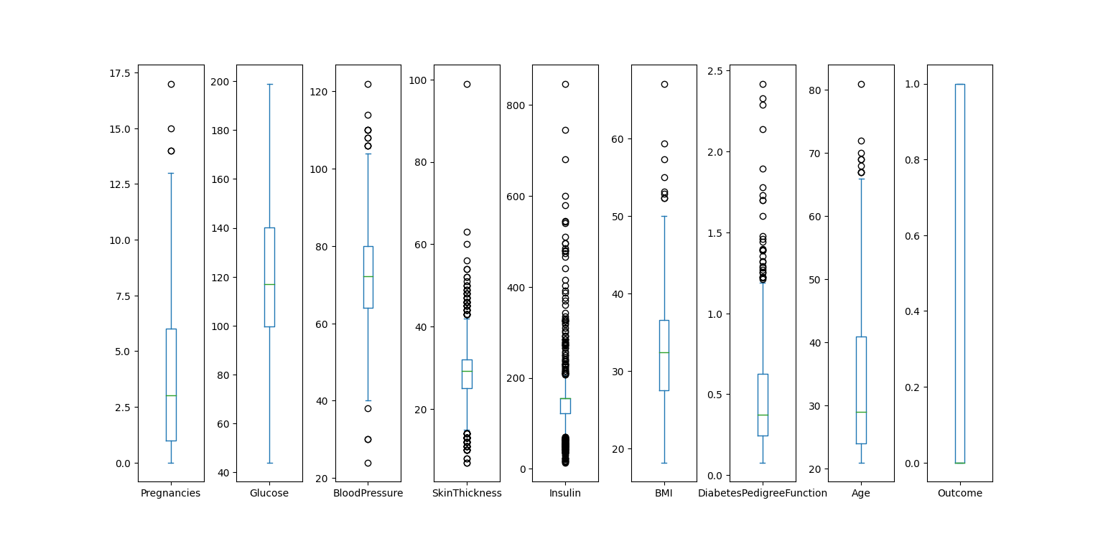

The median of glucose level for people with diabetes was higher than for healthy people. However we can see that in the case of healthy people there is significant number of outliers.

**Covariances**

|  |  |  |  |  |  |  |  |  |  |
| --- | --- | --- | --- | --- | --- | --- | --- | --- | --- |
|  | Pregnancies | Glucose | Blood Pressure | Skin Thickness | Insulin | BMI | Diabetes Pedigree Function | Age | Outcome |
| Pregnancies | 11.354056 | 13.118128 | 8.499282 | 2.458283 | 16.050914 | 0.499584 | -0.037426 | 21.570620 | 0.356618 |
| Glucose | 13.118128 | 926.346983 | 80.394788 | 51.636823 | 1087.239699 | 48.324859 | 1.382151 | 95.401356 | 7.155569 |
| Blood Pressure | 8.499282 | 80.394788 | 146.321591 | 20.503705 | 74.579607 | 23.391407 | -0.011075 | 46.175523 | 0.958140 |
| Skin Thickness | 2.458283 | 51.636823 | 20.503705 | 77.280660 | 118.195534 | 32.782007 | 0.294084 | 13.219905 | 0.902718 |
| Insulin | 16.050914 | 1087.239699 | 74.579607 | 118.195534 | 7228.588766 | 97.375072 | 2.778511 | 136.715802 | 8.694564 |
| BMI | 0.499584 | 48.324859 | 23.391407 | 32.782007 | 97.375072 | 47.267706 | 0.349435 | 2.063312 | 1.022835 |
| Diabetes Pedigree Function | -0.037426 | 1.382151 | -0.011075 | 0.294084 | 2.778511 | 0.349435 | 0.109779 | 0.130772 | 0.027472 |
| Age | 21.570620 | 95.401356 | 46.175523 | 13.219905 | 136.715802 | 2.063312 | 0.130772 | 138.303046 | 1.336953 |
| Outcome | 0.356618 | 7.155569 | 0.958140 | 0.902718 | 8.694564 | 1.022835 | 0.027472 | 1.336953 | 0.227483 |

Covariance is a statistical measure that shows whether two variables are related. Positive covariance means that both variables either increase or decrease, while negative value of this measure means that values of the variables change in opposite directions. In our dataset, positive covariance occurrs between for example blood pressure and glucose, which means that as the level of glucose in blood rises, the blood pressure also rises.

**Correlations**

Next step is correlation to determine the strength of a relationship between variables.

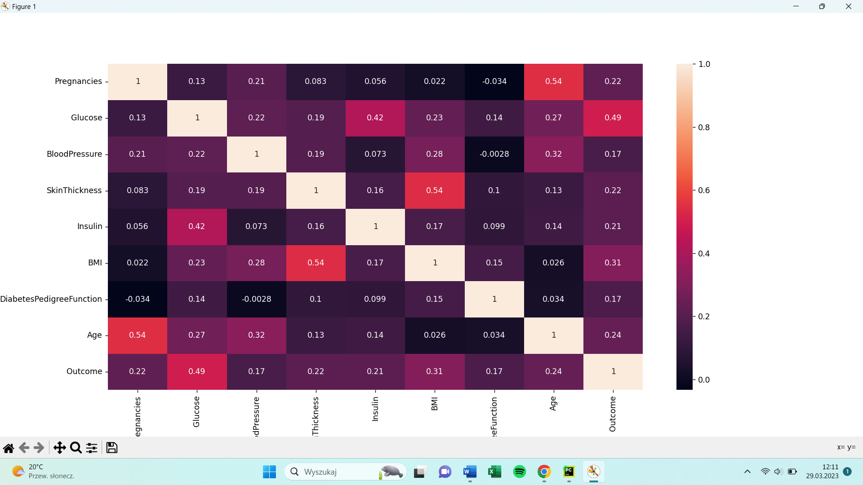

According to the heat map generated for all variables, the highest correlation occurred between:

* Age and pregnancies (0,54)
* BMI and skin thickness (0,54)
* Glucose and outcome (0,49)

The correlation between age and pregnancies is logic. As women get older, their fertility declines and the likelihood of having a successful pregnancy decreases. Therefore, women who are older may have a higher number of pregnancies because they have been trying to conceive for a longer period of time.

1. **Graphs**

Pregnancies by age

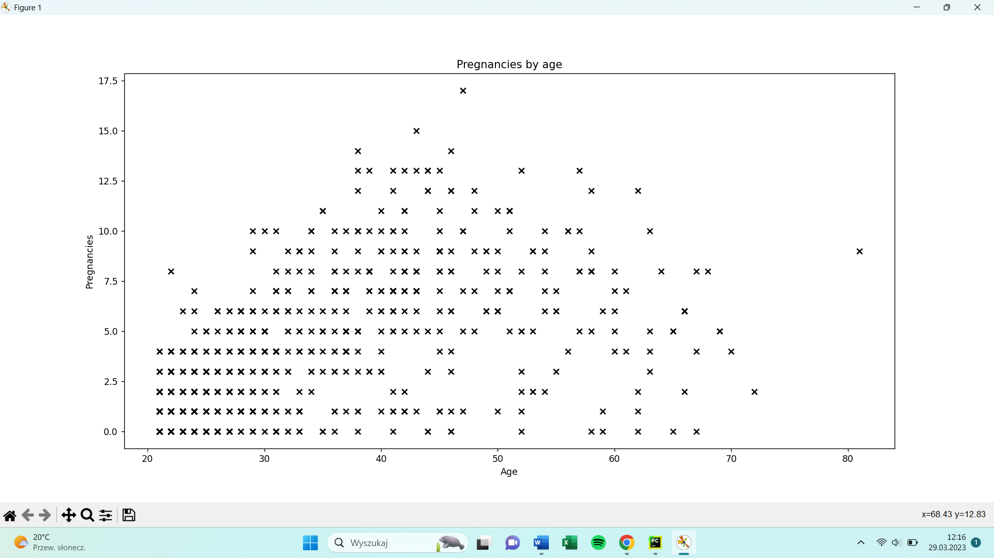

As we can see from the graph shown above, relationship between pregnancies and age is linear. It is also positive, because the number of pregnancies rise along with rise of age.

Skin thickness by BMI

. We can also see one outlier, where skin thickness equals 99 mm.

We can see that increase in glucose does relatively little change in insulin levels. The scatterplot contains some outliers, which may distort the result.

1. **Data transformation**

**Normalisation**

Normalisation scales features between 0 and 1, retaining their proportional range to each other

Example of normalisation for insulin variable:

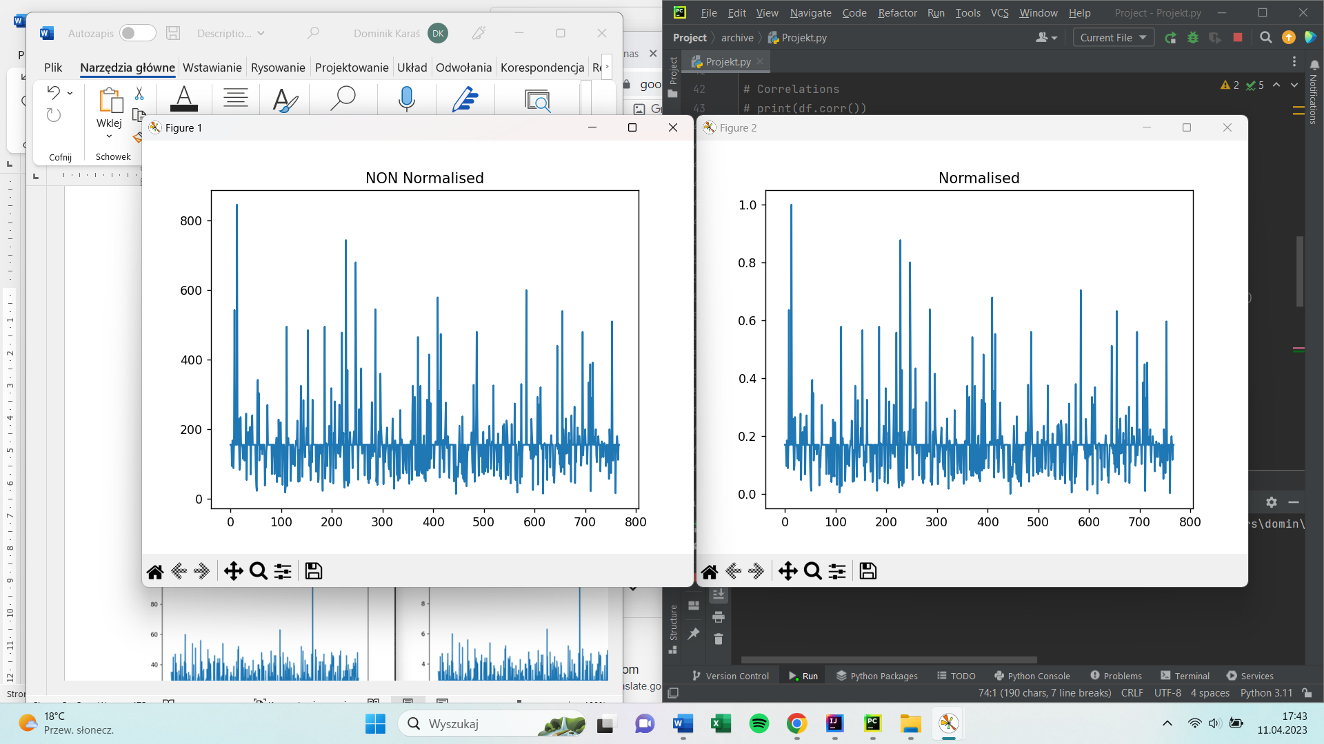

**Standardization**

Standardization scales features to have a mean of 0 and standard deviation of 1.

**Linear Transformation**

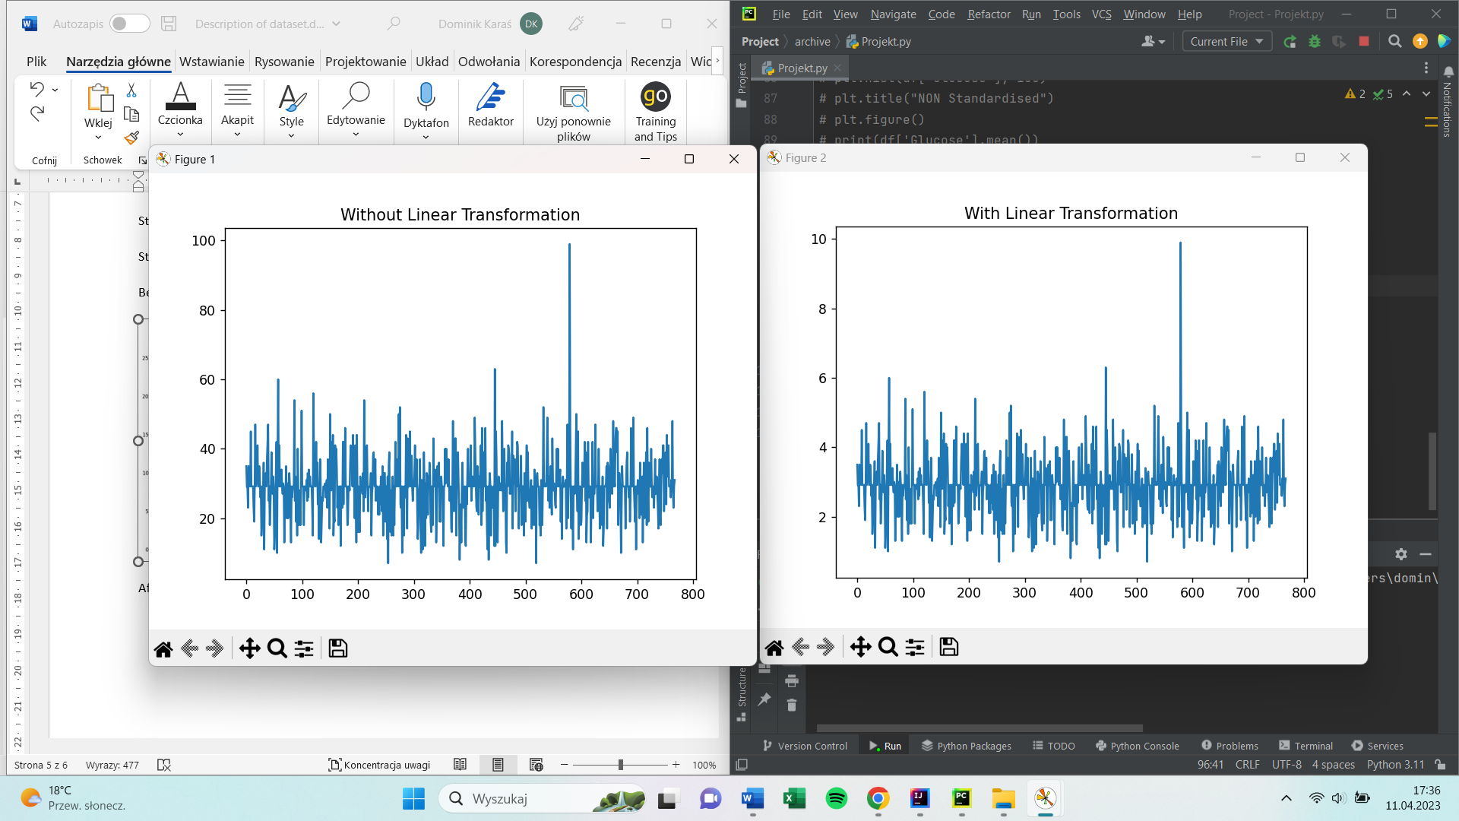

// does number of pregnancies influence blood pressure or other variables

Bmi and age (histogram)

Boxplot for all variables